## System Description

This project aims to build a robot that can collaboratively carry an object with another robot in an open-top maze. This duty’s main requirements are designing a robot which is aware of its surrounding and which can freely, predictably and precisely move. To achieve this purpose, we have designed and built the robot in three main subsystems according to their functions. The robot includes a body part, which is the main chassis and passive components on it, a detection part that is composed of a camera, proximity sensors and algorithms that provides surrounding awareness, and finally movement part with motor drive system, tyres and movement control algorithms. These subsystems are discussed and explained in detail further in the report. Also, detailed block diagrams, flowcharts of these subsystems, technical drawings and general appearance of the robot are provided on Figures AAAAA, BBBB, CCCCCC, DDDDD and EEEEEE, below.

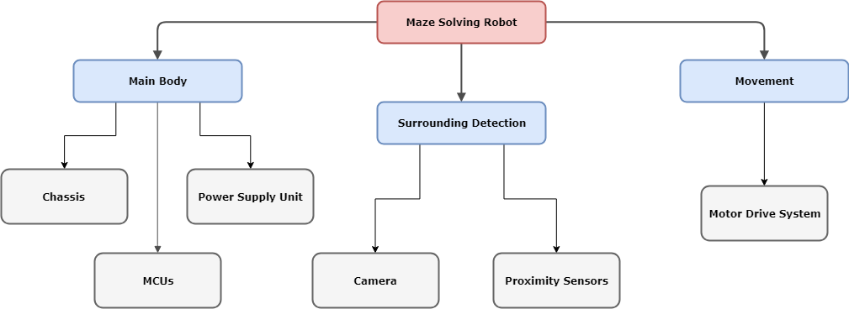

Figure AAAA: Block Diagram of the Overall System

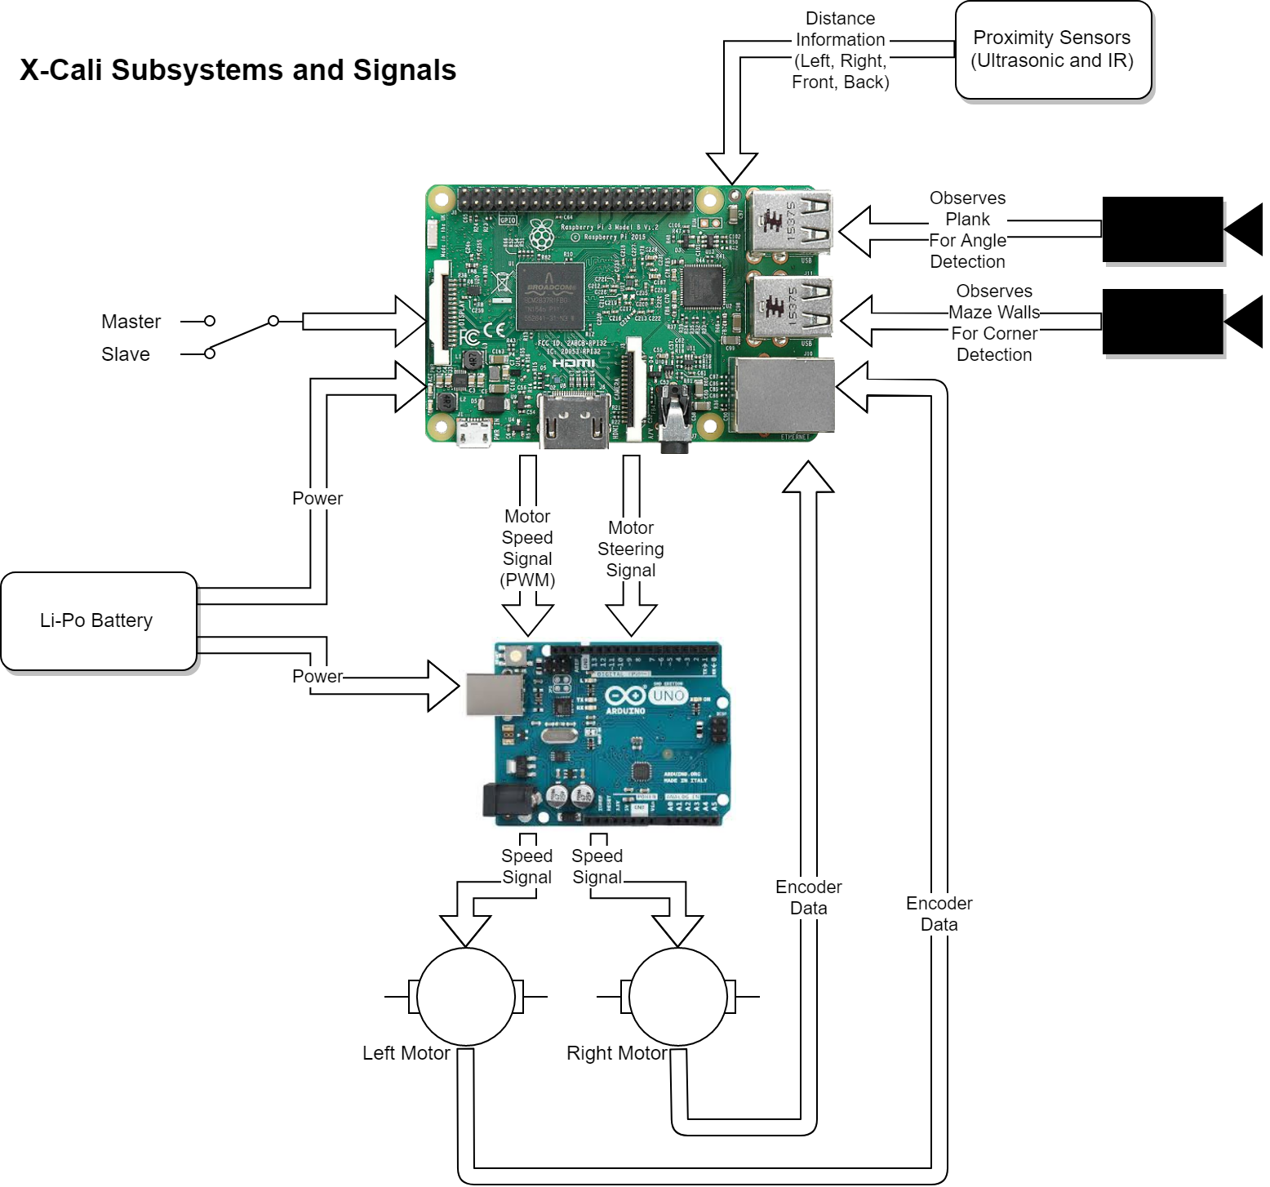

Figure BBBB: Flowchart of the System Functioning

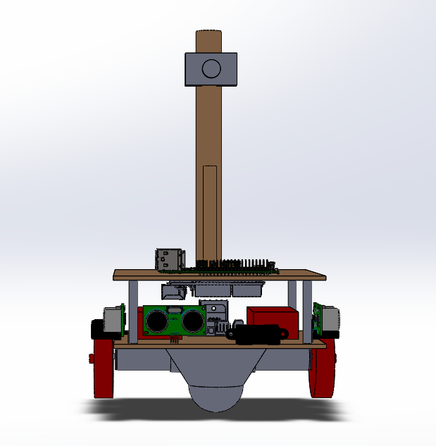Figure CCCCC: Technical Drawing of the Robot (Front View)

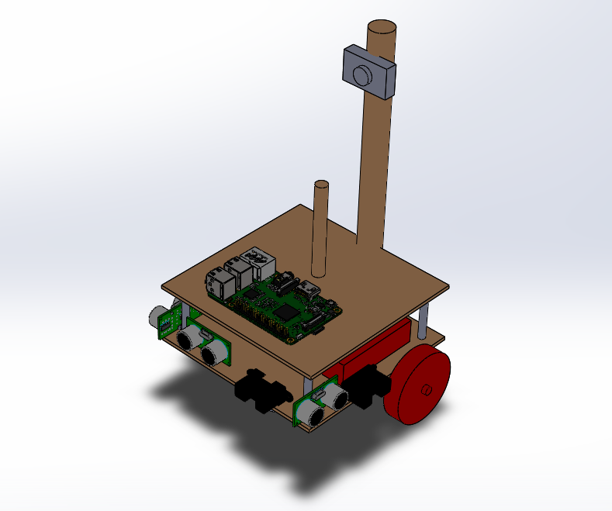

Figure DDDDD: Technical Drawing of the Robot (Isometric View)

**ROBOTUN ŞEKİL Bİ FOTOSU OLSUN BURDA**

Figure EEEEE: General Appearance of the Robot

## Subsystem Analysis

### Main Body:

1. Chassis

The main platform of the robot is manufactured using hardboard considering its lower weight, durability, strength and convenience for mechanical assembly processes. As displayed in Figure (Teknik çizim) above, the robot is composed of two staged hardboard platforms that are 150 mm both in width and in depth. These stages are separated with metal supports that are 45 mm long. It was important for the footprint of the robot to be small because of restrictive standards and high maneuverability.

Two sticks are mounted on the chassis, for the plank and as a camera holder. These sticks are also made of wood, because of its lower weight and strength. Top of the holder stick of the plank is 170 mm above the ground, as determined in Standards Committee. On the holding point, a ball bearing is placed in order to reduce the friction of the plank while rotating. Camera holder is placed behind the plank holder and it is higher than it for a better perspective.

Heavier components are placed on the platform at the bottom, to decrease the level of center of gravity. Another consideration while placing the components is placing electronic parts that are in connection close to each other, to avoid complexity caused by cables and provide easy debugging.

Most of the passive components and motors are mounted on the platforms with screws and nuts to eliminate negative effects of mechanical vibrations on the system. Also, plastic clamps are used where necessary.

1. Power Supply Unit

The robot has two LiPo batteries that are 11.1 V and 1300 mAh. One of these batteries is to supply power to MCUs and the other supplies power to motor drive system. The main reason for using separate batteries is protection of sensitive electronic components from a damaged caused by high current. Also, at startup, motors draw high current, which causes a voltage drop on the other equipments that are connected to same battery. This issue causes a continuous “resetting” problem of MCUs. Batteries are placed on the bottom platform of the robot, as they are heavier components and it is necessary that they are close to the components that are going to be connected to them.

1. MCU’s

The robot includes a Raspberry Pi 3 and an Arduino Uno. Arduino Uno is mainly used for motor driving and controlling purposes, whereas functions such as image processing, decision making are performed using Pi.

### Movement:

The robot has rear wheel drive system. Motion is achieved with two tyres connected to the shaft of two DC motors at the back of the robot and a mad wheel at the front middle of the robot. Mad wheel provides mechanical stability to the system and increases the maneuverability.

In the second iteration of the robot, motors are replaced with DC motors with gearbox and encoders. Encoders are used to obtain instantaneous speed data from the motors, which is necessary for motor control.

Motor control is achieved with an Arduino and using PID control. Control algorithm is designed such that KP, KI and KD parameters are determined using the data retrieved from proximity sensors and instantaneous speed data read by motor encoders.